

Programme Name: **BCS**

Course Code: **CSC 1013**

Course Name: **System Analysis and Design**

Assignment **: First (redone)**

**Submitted By: Submitted To:**

Student Name: **Dipesh Tha Shrestha** Name: **YOGENDRA BAHADUR MAHATA**

Semester: second

Intake:2019

1. Define the system.

=A System is a collection of elements or components that are organized for a common purpose.

A System is a way of working, organizing, or doing something which follows a fixed plan or set of rules.

1. Elaborate concepts of System, Information System and Computer Information Systems.
   1. System – Solar System, Government Rules etc
   2. Information System – Newspapers, Media, can be paper based also
   3. Computer Information System – Software and accessories

Answer:

1. System: A set of things working together as parts of a mechanism or an interconnecting network; a complex whole is also known as system. For example: Solar system is system in which every planets, star, asteroid, meteoroids etc. work as whole.
2. Information System: Information systems are combinations of hardware, software, and telecommunications networks that people build and use to collect, create, and distribute useful data, typically in organizational settings.
3. Computer information systems is the application of technology in managing the needs of businesses, so you’ll get to put your technical skills to work in a business setting. Students in the computer information Systems major learn how to work with companies’ IT systems to solve operations issues.
4. List at least three people at your school or a nearby company who use information systems. List the systems, the position titles of the users, and the business functions that the systems support. [Hint: Banks, ISPs, Restaurants, Departmental Stores]

|  |  |  |  |  |
| --- | --- | --- | --- | --- |
| Name | Organization | Work /Position | System | function |
| Bishnu kapkota | Supreme Academy Higher Secondary School | D.I | Analog Security System | Check the student behaviors and staff behavior. |
| Shyam Shrestha | The Water Solution | Accountant | Fin Pro | Record the financial transaction of the company. |
| Royal Shrestha | Big market | Customer Service Representative | IMS POS Software | Answer all customer inquiries whether it’s a concern, product question , or even a negative review |

= The list of systems, the position titles of the users, and the business functions that the systems support is given below:

1. Discuss in detail about software currently used in Nepal (say, Banks using Globus, T24, Pumori, Mobile Applications such as Khalti).

* **eSewa**

Nepal’s first online payment gateway is a comprehensive online payment solution. With eSewa digital wallet, customers can pay, send and receive money simply using their mobile phone and the Internet instantly. eSewa have been operation since 2009 and have been licensed by Nepal Rastra Bank as Payment Service Provider.

Customers can use eSewa web/mobile application for mobile recharge, electricity bill payment, TV payment, Online travel ticketing, Online shopping, movies ticketing, school/ college fee payment, credit card payment, insurance premium and many more. Similarly, merchants, service providers and retail outlets can receive payments for goods and n

eSewa App is available for both iOS and Android devices and its primary web portal is [www.esewa.com.np](http://www.esewa.com.np/)

* **T24**

**T24** is the most technically advanced banking system in the world today. It is a 24-hour real-time banking application that provides multiple application server support to a huge number of users. The system also eliminates the need to run End Of Day processing. T24 is an integrated core banking solution that is often referred to as “all in one” technology resource. T24 equips financial institutions with all the necessary tools for managing the entire workflow of banking operations from both back and front end in addition to client relationship management. T24 has established strong reputation in financial services market over the past 14 years

* **Pumori**

Pumori banking software is an innovative and reliable software platform designed to build centralize solutions for banks, financial institutions and co-operative sectors. The banking software developer group of Mercantile Office Systems (MOS) created Pumori Banking Software which is a complete banking software solution based on a Microsoft platform (Windows) and Microsoft SQL Server.

* **Globus**

Globus is a software with components and capabilities that includes: A set of service Implementations that Indicate resource management, data alterations service finding and relevant issues. Tools for building web services. A powerful standards-based security prerequisites for authentication and authorisation.

1. Draw the keyboard and explain the shortcut keys used in your daily life.

=The shortcut keys used in daily life are given below:

|  |  |
| --- | --- |
| Shortcut key | Uses and function |
| Ctrl+Z | To reverse your last action, press **CTRL**+**Z**. You can reverse more than one action. |
| Ctrl+X | **Ctrl**+**X** is a **shortcut key** most often used to cut any selected text, image, or other objects. |
| Ctrl+C | **Ctrl**+**C** is a **shortcut key** most often used to copy any selected text, image, or other objects. |
| Ctrl+V | **Ctrl**+**V** is a shortcut key most often used to paste text or other objects from the clipboard |
| Ctrl+A | **Ctrl+A** is a shortcut key most often used to select all text, or other objects while in a graphical user environment. |
| Ctrl +S | **Ctrl+S** is a shortcut key most often used to save the file and document. |

=the diagram of keyboard is given below: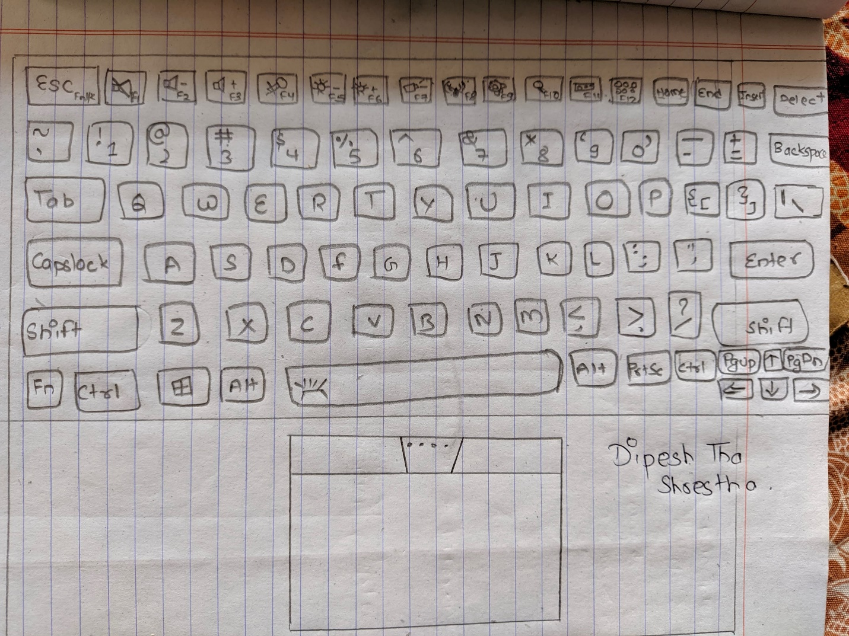

1. List down the ISP ( Internet services Provider) Currently available in Nepal.

=The ISP currently available in Nepal are:

* Vianet

Vianet was established in 1999 in Nepal. As it uses Optical Fiber technology, it stands out from rest. It provides a wide range of internet package including both limited and unlimited internet access.With the growing number of internet users, the need for flexible, quality and cost-effective internet plans is also growing. Keeping these things in mind, Vianet has been providing a stable connection with high-quality internet service to the customers.

* Worldlink

Worldlink which claims to be the largest ISP in Nepal offers FTTH service at a wide range of speed and data package. They serve internet to home, business, and enterprise, and have a good coverage. If you are a home user you may want to stick with Fiber-Home service.

* Subisu

Subisu was one of the best ISPs in Nepal a while back. However, now, users are rating it down. It attracted users because of its speed, reliability & services. It seems to have gone in the opposite direction, though. A lot of users are complaining about its slower speed, long downtime, and other problems.

* Classic Tech

Classic Tech is the best wireless Internet Service Provider in Nepal. It also provides internet via fiber. Classic Tech is used by some well-known Nepali offices like Nepal Police headquarters, NPL, NAC, etc, and are trusted by them. They provide good customer care and a lot of people suggest Classic Tech.

1. Define System Analyst.

=A systems analyst is an information technology professional who specializes in analyzing, designing and implementing information systems.

A systems analyst is a person who uses analysis and design techniques to solve business problems using information technology. Systems analysts may serve as change agents who identify the organizational improvements needed, design systems to implement those changes, and train and motivate others to use the systems.

1. Differentiate System Analyst and Business Analyst  .

|  |  |
| --- | --- |
| **System Analyst** | **Business Analyst** |
| * focus on system specific requirements. | * focuses on the broader context in the business of business changes and systems development for a business. |
| * Based on IT department. | * Bridge between IT and Business |
| * Evaluate technical solution | * Develops the Business Case |
| * Resource efficiencies | * Stakeholder focused |
| * System Testing | * User Acceptance Testing |
| * Good written and mathematical/analytical skills | * Excellent communication skills |
| * Systems focused(IT) | * Application focused(IS) |

1. Define the steps of SDLC.

=The steps of SDLC are:

* Requirement gathering and analysis

During this phase, all the relevant information is collected from the customer to develop a product as per their expectation. Any ambiguities must be resolved in this phase only.

Business analyst and Project Manager set up a meeting with the customer to gather all the information like what the customer wants to build, who will be the end-user, what is the purpose of the product. Before building a product a core understanding or knowledge of the product is very important.

* Design

In this phase, the requirement gathered in the SRS document is used as an input and software architecture that is used for implementing system development is derived.

* Implementation or coding

Implementation/Coding starts once the developer gets the Design document. The Software design is translated into source code. All the components of the software are implemented in this phase.

* Testing

Testing starts once the coding is complete and the modules are released for testing. In this phase, the developed software is tested thoroughly and any defects found are assigned to developers to get them fixed.

Retesting, regression testing is done until the point at which the software is as per the customer’s expectation. Testers refer SRS document to make sure that the software is as per the customer’s standard.

* Deployment

Once the product is tested, it is deployed in the production environment or first UAT (User Acceptance testing)  is done depending on the customer expectation.

In the case of UAT, a replica of the production environment is created and the customer along with the developers does the testing. If the customer finds the application as expected, then sign off is provided by the customer to go live.

* Maintenance

After the deployment of a product on the production environment, maintenance of the product i.e. if any issue comes up and needs to be fixed or any enhancement is to be done is taken care by the developers.

1. Define Prototype

=A prototype is an early sample, model, or release of a product built to test a concept or process. A prototype is the original model, a sample on which to base future designs.

1. Draw  any system diagram and label it.

=Any system diagram is given below:

